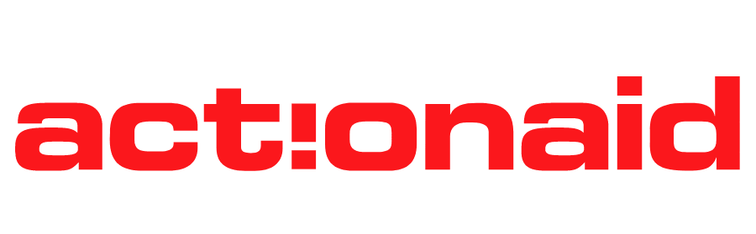
Press Statement
Calls to UNiTE to End Digital Violence Against Women and Girls
Harare, 25 November 2025: ActionAid Zimbabwe (AAZ) joins the global community in launching the 16 Days of Activism Against Gender-Based Violence, commemorated from 25 November to 10 December, with a renewed call to protect women and girls from the rapidly intensifying threat of digital violence. This year’s theme, UNiTE to End Digital Violence Against All Women and Girls, highlights the urgent need for collective action to safeguard rights, dignity, and safety in online spaces.
Digital violence, including cyberbullying, online harassment, hate speech, impersonation, extortion, and the non-consensual sharing of intimate images, has emerged as one of the most pervasive and underreported forms of gender-based violence. In Zimbabwe, 28 percent of women have experienced online GBV, according to the National GBV Strategy (2023–2030). This figure reflects a crisis that cuts across age, geography, income, and political affiliation, silencing voices and undermining participation in public life.
ActionAid Zimbabwe notes that digital violence amplifies the inequalities already faced by women and girls. As climate shocks, economic pressures, and humanitarian crises deepen, women and girls face heightened risks. Access to reliable, safe, and affordable digital information becomes even more essential for decision-making, protection, livelihoods, and health. Creating a just and inclusive future means ensuring that every woman and girl can use digital tools with confidence, dignity, and freedom from harm.
ActionAid Zimbabwe urges government, regulators, and digital platforms to implement the Cyber Security and Data Protection Act with a strong gender lens, ensuring that women and girls are fully protected from online harassment, exploitation, and abuse. Effective implementation must include secure reporting systems, survivor-centred referral pathways, gender-responsive data protection oversight, and rigorous prosecution of offenders.
In marking the 16 Days of Activism, ActionAid Zimbabwe calls for coordinated national action to prevent and respond to digital violence:
- Centre women and girls’ voices in legislation, policy formulation, and digital governance
- Increase public financing for feminist, community-based programmes that build digital safety, resilience, and awareness
- Strengthen legal frameworks and enforcement to deter perpetrators and protect survivors’ privacy, safety, and rights
- Ensure rapid takedown systems for harmful content and establish clear, survivor-friendly digital GBV reporting and referral pathways.
- Hold political actors, platforms, and institutions accountable for preventing online misogyny, political abuse, cyberstalking, and image-based violence
As a feminist organisation, ActionAid Zimbabwe reaffirms its commitment to defending the rights of women and girls across all spaces—physical, virtual, and public. We call on government, civil society, technology companies, youth, media, and communities to work together to create a digital environment where every woman and girl can speak, learn, work, and lead without violence. Ending digital violence is not optional. It is a national imperative.
For more information:
ActionAid Zimbabwe Interim Country Director Dr Selina Pasirayi on: Email: info.zimbabwe@actionaid.org Twitter: https://twitter.com/ActionAidZim
Facebook: https://www.facebook.com/ActionAidZimbabwe/
Website: https://zimbabwe.actionaid.org/

